Project Report

ON

**“ELECTRICITY GENERATION FROM PIEZOELECTRIC FORCE SENSOR”**

Submitted in partial fulfilment of the requirements for the partial completion of

**MINI PROJECT (19EC3PWMP1)**

IN

**ELECTRONICS AND COMMUNICATION ENGINEERING**



**VISVESVARAYA TECHNOLOGICAL UNIVERSITY, BELGAUM**

SUBMITTED BY:

**Niteeshkumar H V 1BM19EC098**

**Nitesh R** **1BM19EC099**

**Padmaj U Naik**  **1BM19EC101**

**Pavan Kumar M 1BM19EC102**

Under the Guidance of

Mr.Madhusudhan K N

(Assistant Professor, ECE, BMSCE)



Department of Electronics and Communication Engineering

**B.M.S COLLEGE OF ENGINEERING**

(Autonomous College Affiliated to Visvesvaraya Technological University, Belgaum)

Bull Temple Road, Basavanagudi, Bangalore-560019

**B.M.S COLLEGE OF ENGINEERING**

(Autonomous College under VTU)

**Department of Electronics and Communication Engineering**



**CERTIFICATE**

This is to certify that the project entitled **“ELECTRICITY GENERATION FROM PIEZOELECTRIC FORCE SENSOR”** is a bonfide work carried out by **Niteesh kumar H V(1BM19EC098), Nitesh R(1BM19EC099), Padmaj U Naik(1BM19EC101),** and **Pavan Kumar M(1BM19EC102)** in partial fulfilment for the partial completion of “**Mini Project(19EC3PWMP1)** during the academic year 2020-21.

**Mr. Madhusudhan K N** **Dr. Arathi R Shankar Dr. B.V. Ravishankar**

Assistant Prof., ECE, BMSCE HOD, ECE, BMSCE Principal, BMSCE

**External Examination:**  **Signature with date:**

1.

2.

**DECLARATION**

We undersigned students of third semester B.E in Electronics and Communication Engineering, BMS College of Engineering, Bangalore, hereby declare that the dissertation entitled **“ELECTRICITY GENERATION FROM PIEZOELECTRIC FORCE SENSOR”**, embodies the report of my project work carried out independently by us under the guidance of Mr. Madusudan K N (Assistant Professor), E&C Department, BMSCE, Bangalore in partial fulfilment for the award of Bachelor of Engineering in Electronics and Communication from Visvesvaraya Technological University, Belgaum during the academic year 2020-2021.

We also declare that to the best of our knowledge and belief, this project has not been submitted for the award of any other degree on earlier occasion by any student.

Place: Bangalore

Date: 12/03/2021

Niteeshkumar H V 1BM19EC098

Nitesh R 1BM19EC099

Padmaj U Naik 1BM19EC101

Pavan Kumar M 1BM19EC102

**ABSTRACT**

Recent advancement in information technology is leading towards a pressurized world altogether by replacing the traditional way of living with technology. With the development of technology and the continuous improvement of people's living standard, people are in pursuit of automated, intelligent and convenient control systems. To make peoples life easier automation systems are required. For example, we find it difficult to get out of bed and switch off the lights at night. It would be very convenient if we could control the lights through our mobile. That’s the main idea of our project. These systems are mainly helpful for older people of our society who are not mobile enough. Many existing, well-established automation systems are based on wired communication.

With the rising power of technology, we are able to accomplish things at a much quicker rate. We have at the touch of a button access to large amounts of information due to the capability of computers and the Internet. Not only has technology given us more information, but it also has given us the ability to communicate, organize, and manage our time. The communication between devices can be used to provide control of various devices to the user.

**ACKNOWLEDGEMENT**

Any achievement, be it scholastic or otherwise does not depend solely on the individual efforts but on the guidance, encouragement and cooperation of intellectuals, elders and friends. A number of personalities, in their own capacities have helped us in carrying out this project work. We would like to take this opportunity to thank them all.

We express profound gratitude to respected principal **Dr. B. V. Ravishankar,** BMS College of Engineering for providing a congenial environment to work in. Our sincere gratitude to **Dr. Arathi R Shankar,** Head of the Department, Electronics and Communication Engineering for encouraging and providing this opportunity to carry out the project in the department.

We would like to thank our guide **Mr.Madusudan K N ,** Assistant Professor, Department of ECE who helped us in all the ways to carry out the project work. He stood beside and guided us in every step. Our special thanks to **Sanjana T**, Assistant Professor, Department of ECE who helped us in project.

We would like to share the joy completing the project to all the team members**.** We thank all our professors for providing the basic knowledge without which this project wouldn't have been possible. Last but not the least we thank our family and friends, who made their valuable support compelled us to maintain a standard throughout our endeavour.

Niteeshkumar H V – 1BM19EC098

Nitesh R – 1BM19EC099

Padmaj U Naik – 1BM19EC101

Pavan Kumar M – 1BM19EC102

**CONTENTS**

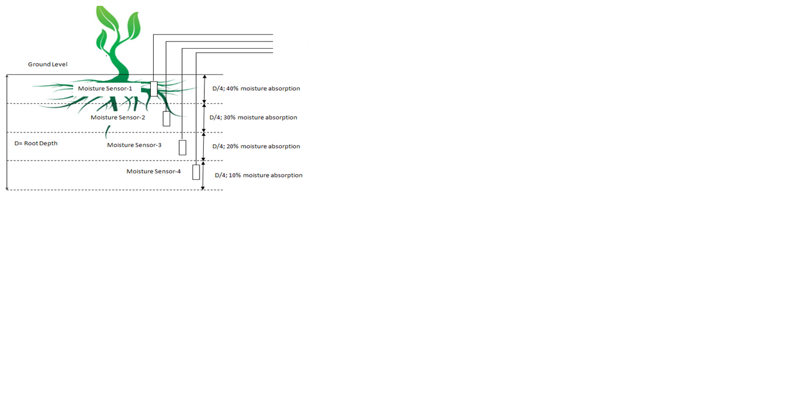

Data acquisition model

SIM900A

Display

Battery

optocoupler

Relay

Soil temperature sensor

Battery level indicator

**TOPIC PAGE NO**

**Chapter 1: Introduction 1**

1.1 Introduction

1.2 Problem definition

1.3 Objective of the project

**Chapter 2: Literature survey 3**

**Chapter 3: Methodology and Implementation 7**

3.1 Block diagram

3.2 Project flow

3.3 Hardware architecture

3.3.1 Circuit diagram

3.3.2 Circuit Components

3.3.3 Component Description

3.4 Circuit Working

**Chapter 4: Results and Discussion**  **18**

**Chapter 5: Conclusion and Future Work 21**

5.1 Conclusion

5.2 Future Work

**REFERENCES 22**

**ANNEXURE**       **23**

**1.1 Introduction Chapter-1: INTRODUCTION**

**Electricity Generation from Piezoelectric Sensor**

In this mini-Project we will generate electricity from piezoelectric sensor by using the phenomenon of PIEZOELECTRIC EFFECT. Piezoelectric Effect is the ability of certain materials to generate an electric charge in response to applied mechanical stress. The piezoelectric crystals exhibit the piezoelectric effect. This piezoelectric effect having two properties:

First one is the direct piezoelectric effect which means that material has ability to convert mechanical strain into electrical charge. Second one is the converse effect, in which the applied electrical potential converted into mechanical strain energy. In this project we are using direct piezoelectric effect to generate electricity

**1.2 Problem Definition**

In this modern lifestyle there is a need for energy conservation, our project actually deals with the energy to be precise electricity. By using the concept of piezoelectric effect, we are generating electricity which will partially contributing to the battery life of Laptop (Or any other electrical devices where force is applied on it).

When an appropriate pressure is applied on Piezoelectric sensor, they produce electricity. The output of this sensor is connected to the battery of the laptop which gets charged simultaneously while discharging which increases the battery life/battery discharge rate.

For example, let us assume the laptop on continuous usage with peak brightness gives a battery backup of about 4 hours, by employing this concept the usage of same laptop is increased to about >6hours (depends on the many factor which will be discussed in the further slides).

**1.3 Problem Solution**

So how Exactly we can produce electricity is produced using piezoelectric force sensor? These sensors are placed under the keyboard of Laptop, so as we keep on typing, we apply pressure on the keyboard keys, which applies the force on the sensor when appropriate force is applied the sensor starts producing electricity which is used to recharge the battery simultaneously. Thus, increasing the battery discharge rate. Which in turn saves lots of electricity.

If we take IT Companies as an example, in a day thousands of employees used their laptop and by employing this method the dependency on electricity can be greatly reduced

The objective of this project is reducing the usage/dependence on electricity for the equipment's where force is applied on it. Which partially contributes to the recharging of the battery.

**Chapter-2: Literature survey**

In the recent years piezo materials have been implemented in various domains as alternative to the petroleum such exhaustive products and also as a concern towards the environment.

Many countries have adopted projects for large harvesting of the electrical energy through piezo materials.

Let us look an example of the piezoelectric roads in California.

Railways in japan etc

Piezoelectric devices, used for harvesting the vibrational energy of roads and walkways due to traffic, can produce electrical energy that is predictable (based on traffic patterns), and locally storable.

Piezoelectric devices generate electrical energy by means of a piezoelectric crystal. The crystal, placed about 5 centimeters below the surface of the asphalt, slightly deforms when vehicles travel across the road, thereby producing electrical current. These devices have been implemented by the East Japan Railway Company (under pedestrian subway station gates) and by Innowattech (under roads in Israel). Innowattech has advertised that these devices, if planted along a one-kilometer stretch of road, could provide an average of 400 kW of power, enough to power 162 Western-U.S. homes. [1,2] These data suggest that piezoelectric energy harvesting is a competitive, clean alternative energy source. In response to these findings, in 2011 California state assemblyman Mike Gatto proposed Assembly Bill 306 to develop this technology for Californian roads. [3,4] However, it is unclear whether the data truly reflect the physical limitations of piezoelectric energy harvesting.

The generating capacity of piezoelectric devices can be crudely over-approximated by assuming that the vibrations in the road are caused by traffic alone, and that each "vibration event" from one vehicle is independent of another (i.e., the vibrations are sufficiently dampened before the next vehicle passes). Under these assumptions, the total energy harvested by piezoelectric devices along a one-kilometer stretch is at most the number of cars that pass multiplied by the vibrational energy that one car transfers to the road. This vibrational energy can be over-approximated by the energy that each car consumes and puts to mechanical work across this stretch. In other words, the energy a car loses to vibrations in asphalt must be less than the energy a car puts to mechanical work over the one-kilometer stretch. This value can be computed by multiplying the energy consumed from gasoline by thermal efficiency.

|  |  |  |
| --- | --- | --- |
| Expended Energy | = | (Gasoline Used) × (Energy Density of Gasoline) × (Thermal Efficiency) |
|  | = | 1 km × 0.621 mi/km × 2.8 kg/gal × 4.43 ×107 J/kg × 0.4  20 mi/gal |
|  | = | 1.54 MJ |

This overestimation provides an appropriate upper bound to the amount of energy absorbed by piezoelectric devices from one car moving across a one-kilometer strip (i.e., no more than 1.5 MJ). Of course, some of this "mechanical" (i.e., non-thermal) energy is lost as various forms of friction and used for other processes inside the vehicle (such as air conditioning), and not nearly all of the vibrational energy will be absorbed by the devices in the road. If the devices are embedded on a busy street, then such a street will generate at most this amount of energy multiplied by the number of cars moving across the street. If such a street or highway sees an average of 600 vehicles per hour (as assumed by Innovates), then the energy provided by these devices on a one-kilometer stretch could power at most 105 Western-U.S. homes (with a total of 257 kW). [1,2] If the calculation were repeated for only 18-wheelers (with about 5 mpg), the maximum number of homes a one-kilometer strip could power would increase to 421 homes (with 1 MW).

However, a more reasonable approximation can be made by using the fact that approximately 5% of the energy consumed by the car is lost as rolling friction, although rolling friction accounts for both internal friction in the wheels and friction due to the asphalt. [5] By replacing thermal efficiency in the above equation with 5%, the amount of energy released into the ground for one 20 mpg car would decrease to 0.19 MJ. This one-kilometer strip could then power at most 13 homes (32 kW) for the 20-mpg car, or 52 homes (128 kW) for an 18-wheeler. For this calculation, there is still a major assumption that all the vibrational energy of the road is captured by piezoelectric devices.

It is not clear whether the numbers currently used to quantify generating capacity are misguided or simply misreported, but under the optimistic assumptions stated above, piezoelectric devices over a one-kilometer strip of road will generate power for only about 15 homes. Unless the road carries only 5 mpg vehicles (or many more than 600 vehicles per hour), it is unlikely that anywhere near 400 kW of power can be generated from one kilometer.

**Profitability**

With the price of gasoline hovering around $4 a gallon for the past year, the cost of driving a 20-mpg car across one kilometer is about $0.124. And by recent retail prices of residential electricity on the West Coast, the 0.19 MJ generated by one car costs about $0.0064, or about one twentieth the cost of the gasoline burned across this one-kilometer strip. [6] At this rate, the road will generate a revenue of $33,565 per year.

As an approximate, the price of a piezoelectric device can be estimated by its most expensive element, namely the piezoelectric component. This component, according to Innowattech's patent, is comprised of about 50% lead-zirconate titanate (PZT) ceramic and is about 14×14×2 cm3 in dimension. [7] Given that piezoelectric sheets of the same material currently cost $165 in bulk from Piezo Systems (for 100 sheets of 10.64 cm3 each), the cost per cm3 of this material is about $0.155. Since the devices are embedded 30 cm apart from each other and in two rows per lane, a kilometer of a two-way street will contain 13,333 devices, each device costing $30.39, adding to a total of $405,253. Even without considering the manufacturing or installation costs, it would take about 12 years to earn back this amount from the device revenue.

**Chapter-3: Methodology and Implementation**

**3.1 Block Diagram**

Block diagram for energy conversion

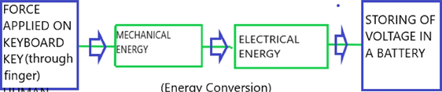

**Block diagram of Charging the Battery**

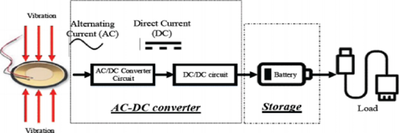

**3.2 Project flow**

**Constructing and Checking for Single Key**

**Increasing the current and Voltage by series and parallel connection**

**Checking the output using MULTIMETER**

**Deciding and Getting Components**

**Development of Project Idea**

**3.3 Hardware Architecture**

**3.3.1 Circuit diagram**



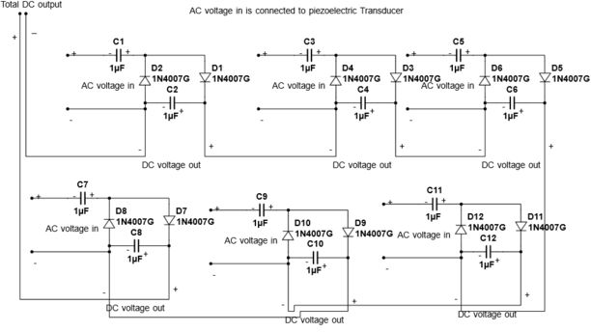

**3.3.2 Circuit Component**

* Piezoelectric elements
* Hook-up wire
* Capacitors
* Diodes
* PVC sheet
* Glue

**TOOLS:**

* Soldering Iron
* Multimeter

**3.3.3 Component description**

* **Piezoelectric Elements:** They consists of Piezoelectric Sensor which plays important role in generating voltage in response to applied strain/force.
* **Hook-up wire:** Hook up wires, also known as lead wires, are single core insulated cables used in the internal wiring of electronic and electrical equipment.
* **Capacitors:** Capacitors are the device which holds the charge, and here in this case it plays a major role, when the output of the sensor is low (due to some factors) the charged capacitor discharges, ensuring the continuous supply of energy and thus not causing any sort of damage to battery.
* **Diodes:** Used for the purpose of Rectification.
* **PVC Sheet:**  Polyvinyl chloride (PVC) is one of the most widely used plastics in the world. It is lightweight on the device is fabricated.
* **Glue:** For joining parts if required.
* **Soldering Iron:** A soldering iron is a hand tool used in soldering. It supplies heat to melt solder so that it can flow into the joint between two workpieces. A soldering iron is composed of a heated metal tip and an insulated handle

**3.4 Circuit working**

* **PIEZO ELECRIC TRANSDUCER**

         A piezoelectric plate is a device that uses the piezoelectric effect to measure pressure, acceleration, strain or force by converting them to an electrical charge. Piezoelectricity is the electricity generated by piezo element by effect called the piezoelectric effect. It is the ability of certain materials to generate an AC (alternating current) voltage when subjected to mechanical stress or vibration, or to vibrate when subjected to an AC voltage, or both. The most common piezoelectric material is quartz. Certain ceramics, Rochelle salts, and various other solids also exhibit this effect. When a sound wave strikes one or both sides of the plates, the plates vibrate. The crystal picks up this vibration, which it translates into a weak AC voltage. Therefore, an AC voltage arises between the two metal plates, with a waveform similar to that of the sound waves. Conversely, if an AC signal is applied to the plates, it causes the crystal to vibrate in sync with the signal voltage. As a result, the metal plates also vibrate and produce an acoustic disturbance.

The main principle for this process is "The piezo electric effect" The piezo electric effect:

Piezo electric effect is generation of electric charge by a crystalline material upon subjecting it to stress 

This effect naturally exists in crystals like quartz, polymers like PVDF.

Piezoelectric Effect in Quartz

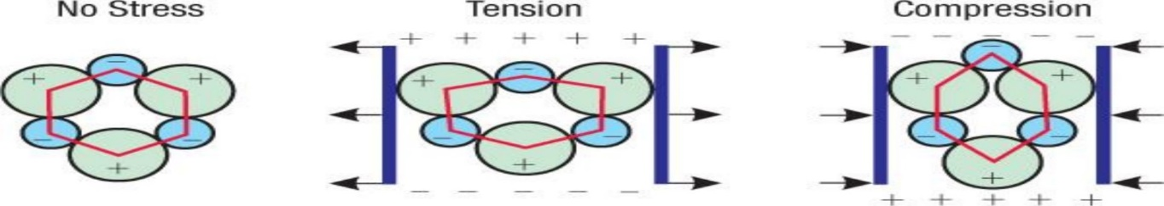

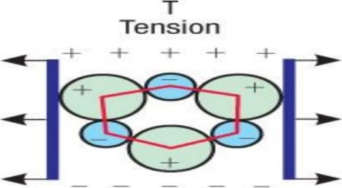

A simple example to understand the phenomena by considering a helix quartz crystal .in a single cell there are 3 Si atoms and 6 oxygen atoms lumped in pairs this is viewed along z direction. Each silicon carries 4 positive charges Si+4 and a pair of oxygen carries 4 negative charges 02-2 making the cell electrically neutral under no stress condition.

When external force is applied along x direction the lattice is deformed.

lf a compressive force is applied the atoms in the crystal are shifted such that +ve charge is built up in silicon atom side and negative charge at oxygen pair side. And opposite charges are built up when tensile force is applied .so when the Force is applied along x axis charges are developed in y axis (perpendicular).

With this it is clear that crystalline materials can develop electric charges on the surface perpendicular to applied force on mechanical deformation. To pick up this charge, conductive electrodes are attached to the crystal in the opposite sides of the cut (y axis in this case).

Using this property of piezo materials, we can incorporate them in fields where mechanical vibrations occur to generate electricity.

Electrodes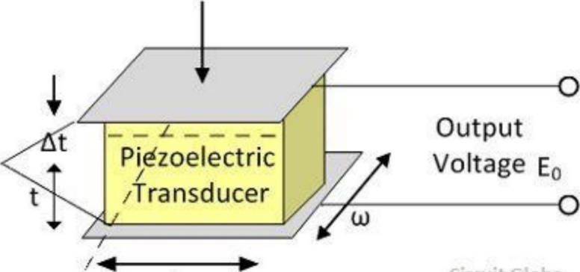

* **VOLTAGE AMPLIFICATION**

       In our project we used Villard Cased to convert AC supply to DC and amplify the voltage. We chose Villard cascade because it rectifies and amplify the input from the source simultaneously by using diodes and capacitor.

* **VILLARD CASCADE**

A voltage multiplier is an electrical circuit that converts AC electrical power from a lower voltage to a higher DC voltage, typically using a network of capacitors and diodes. Voltage multipliers can be used to generate a few volts for electronic appliances, to millions of volts for purposes such as high-energy physics experiments and lightning safety testing

The most common type of voltage multiplier is the half-wave series multiplier, also called the Villard cascade.

In the project we used piezoelectric transducer of ceramic type. Piezo transducer generates AC voltage when we apply pressure on piezoelectric transducer. As AC voltage cannot sum up each other, we have to convert AC voltage to DC voltage. We are converting AC to DC because AC voltage cannot sum up but DC voltage can sum up in series. But in process of converting AC to DC we may lose some energy. If we use full wave reflection bridge to convert AC to DC. We get approx. 80% of energy generated by transducer. (Here we are getting nearly 20% of energy loss). If we connect each piezoelectric transducer with each full wave rectifier bridge and connect them in series, we may lose large amount of energy than released from transducer, then we may not get appreciable output.

By a long research on this concept, we found a solution, that is Villard cascade which is also called as voltage multiplier. Here by applying pressure on the piezoelectric transducer, it generates the AC output. That AC output is connected to Villard cascade (voltage multiplier). By connecting the voltage multiplier, the output will in DC with some voltage boosting. By using voltage multiplier, we reduced rectifier bridge and voltage booster.



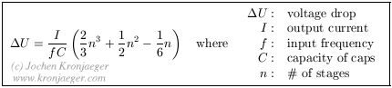

**THE BASIC BLOCK DIAGRAM OF THE PROPOSED MODEL**

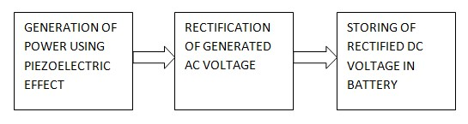

It consists of 3 main blocks

(a) piezoelectric power generation

(b) rectification

(c) storage of DC voltage. (AC voltage is generated from the piezoelectric material which is rectified by the rectification block and then it is stored in a storage device such as a battery)



It consists of five main parts which are of a piezoelectric generator, AC-DC converter, DCDC converter, energy storage device and a load.

•  Here Different block has specific function and operational to produce useful electricity.

•  The first block is piezoelectric transduce, also known as a piezoelectric sensor. The piezoelectric sensor is functional to convert the vibration energy into electrical energy. The energy conversion will take place when the stress applied to the piezoelectric disk surface.

•  The second block is the AC-DC converter circuit. The function of this block is to convert the AC source to the DC source using several types of AC-DC converter circuit.

•  The third block is a DC-DC converter circuit that typically employs a DC-DC converter, mainly to match the source voltage with the battery charging level.

•  The fourth block is storage that usually use a battery to store the charge from the source. Therefore, the charge stored in the battery could be used to energize and power of the application

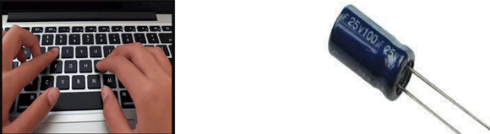

**Chapter-4: Results and Discussion**

**RESULTS**

If we use Bridge rectifier in the project to convert AC to DC. We will get approximately 80% of energy generated by transducer. If we connect each piezoelectric transducer with each full wave rectifier bridge and connect them in series, we may lose large amount of energy than released from transducer, then we will not get appreciable output voltage.

Instead of bridge rectifier we can use Villard cascade which is also called as voltage regulator.

**The practical circuits are shown below**

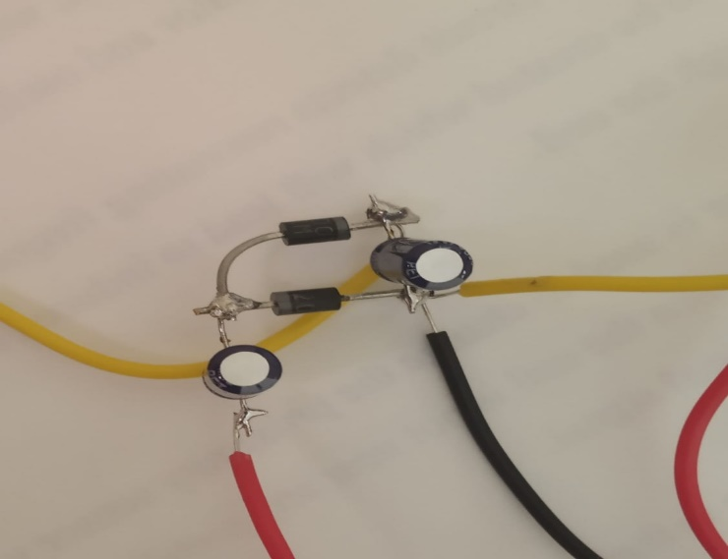

Soldered (permanent)

Connection

Of Circuit shown Left side

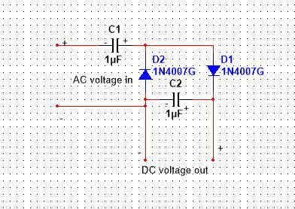

Schematic diagram of Circuit Connection

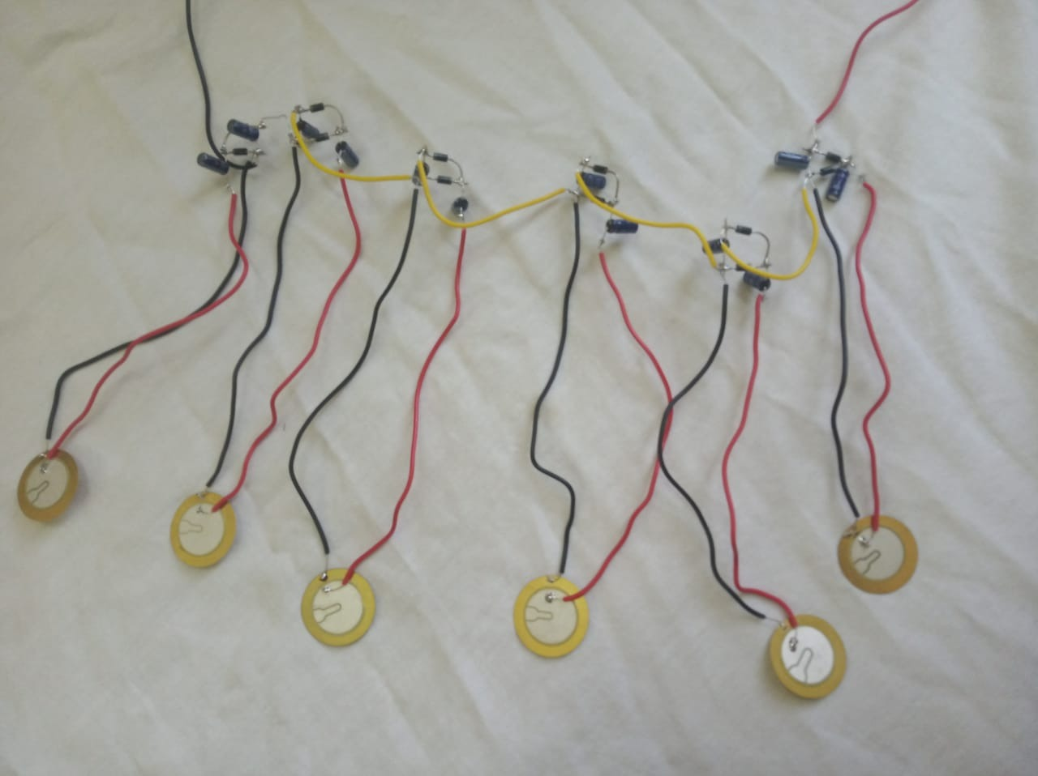

We observed that each piezo plate has the ability to produce up to 12V, during typing the force applied on the key is not sufficient produce appreciable amount voltage, and it can produce maximum up to 2V. So, by connecting many piezo plates in series manner in order to get more than 12V and 12V is sufficient to charge the laptop.

The amount of voltage produced when we apply a force on a key is approximately 2V, by connecting some of the piezo plate in series manner in order to get 12V and the current produced is in micro ampere, current is also increased by connecting some rows in parallel manner.

**Proof:**

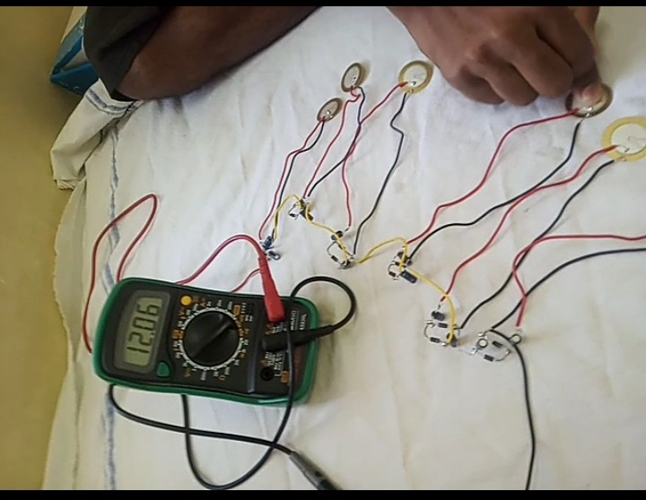

After getting 12V dc and small amount of current, we stored in Capacitor. And we can use this energy as an emergency backup for laptop charging. To store in lithium-ion battery we need to use Zener diode before giving to the battery.

**Chapter-5: Conclusion and Future Work**

The design of the proposed energy conservation system for laptop keyboards has been presented in this paper. The design presented here will be quite effective in providing an alternate means of power supply for the mentioned devices during emergency.

Further, the approach presented in this paper can be used for many other applications where there is scope for similar kind of energy conservation. For example, in calculator, mobile phones etc

Also, instead of contributing the generated voltage in laptop battery, we can store it in separate battery and can use that voltage in other domains where the device will have the capacity to store small amount of voltage in its battery.

**Conclusion**

Generating capacity and profitability are two important factors to consider in choosing this energy alternative. There is currently a significant cap on the generating capacity. Net profits will only be seen after at least 12 years, as an underestimate. There are also many more "costs," besides the financial costs of manufacturing and installation, to take into account, such as the environmental impact of manufacturing the PZT ceramics used in Nonwitch’s devices. While piezoelectric devices are gaining popularity, they are less capable than previously claimed because of physical limitations.

**Reference**

<https://www.google.co.in/>

<https://en.wikipedia.org/wiki/Main_Page>

<https://www.comsol.co.in/multiphysics/piezoelectric-effect>

<https://www.explainthatstuff.com/piezoelectricity.html>

<https://www.ijraset.com/fileserve.php?FID=3950>

<https://qph.ec.quoracdn.net/main-qimg-9dd6cb7da9b4cba6ffd9d6f47d0dbce3>